Name: __________________________ Date:_____________________ Class Period: ___________
Mesopotamia Vocab and Map Assignment
Find the definitions for the following terms using a reputable site on the internet. DO NOT just Google the definitions. Please use a site specific to Mesopotamia.
Mesopotamia-

Tigris River-

Euphrates River-

Sumer-

Levee-

Irrigate-

City-state-

Gilgamesh-

Empire-

Hammurabi-

When you are done, please use the following map to complete the second part of the assignment.
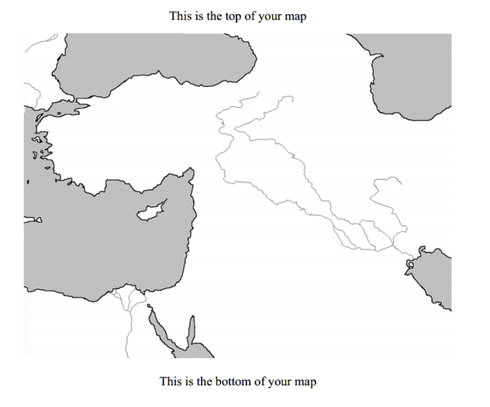
Directions:
1. Shade the gray areas with a blue colored pencil.
2. Outline the rivers on the map with a blue colored pencil as well.
3. LIGHTLY shade the land areas ONE color (Suggestions: light brown, orange, or yellow).
4. Draw a compass rose that indicates North, South, East, and West in the bottom corner (use the map in the atlas to determine where “North” is; if you’re not sure what a compass rose looks like, try to find an example of one on the maps in the atlas).
5. Label the following continents using CAPITAL letters: AFRICA, ASIA, and EUROPE.
6. Label the following bodies of water:
Mediterranean Sea Persian Gulf
Tigris River Caspian Sea
Euphrates River Red Sea
7. Label the following land forms (for mountains, indicate they are mountains by drawing a
symbol next to the label like this: ^^^):
Zagros Mountains Arabian Desert Sinai Desert Syrian Desert Taurus Mountains
8. Outline, lightly shade in a new color, and label the area known as the “Fertile Crescent”.
9. Outline, lightly shade in a new color, and label the area known as “Mesopotamia”.

